**PROJECT DESIGN PHASE - II**

**DATA FLOW DIAGRAM & USER STORIES**

|  |  |
| --- | --- |
| **Date** | **07.11.2022** |
| **Team ID** | **PNT2022TMID24776** |
| **Project Name** | **Smart Farmer - IoT Enabled Smart Farming Application** |

**Data Flow Diagrams:**

A Data Flow Diagram (DFD) is a traditional visual representation of the information flows within a system. A neat and clear DFD can depict the right amount of the system requirement graphically. It shows how data enters and leaves the system, what changes the information, and where data is stored.

* The different soil parameters temperature, soil moistures and then humidity are sensed using different sensors and obtained value is stored in the IBM cloud.
* Arduino UNO is used as a processing Unit that process the data obtained from the sensors and whether data from the weather API.
* NODE-RED is used as a programming tool to write the hardware, software, and APIs. The MQTT protocol is followed for the communication.
* All the collected data are provided to the user through a mobile application that was developed using the MIT app inventor. The user could plan through an app, weather to water the crop or not depending upon the sensor values. By using the app they can remotely operate to the motor switch.

DATA FLOW DIAGRAMS

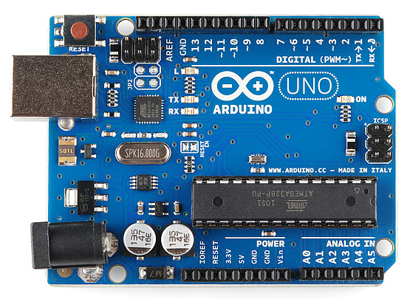 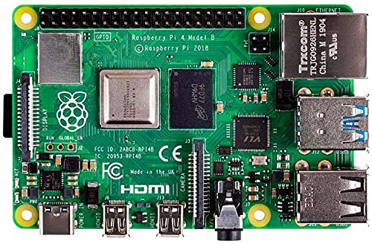

**ARDIUNO-UNO RASPBERRY-PI**

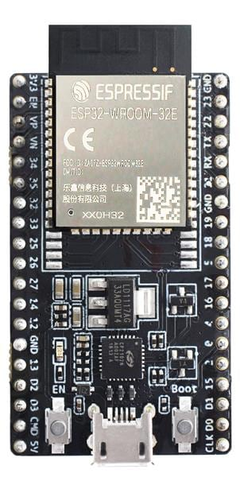

**ESP- 32 KIT**



**IBM WATSON PLATFORM**





**USER INTERRFACE**





**USER MOBILE APP**

WATER LEVEL

MOISTURE

HUMIDITY

TEMPRATURE

The desired soil moisture content depends on the field capacity (FC) and the permanent wilting point (PWP). FC means how much water the soil can hold after the excess drains off.it displays the balance of water and air in the grounds pores.

When the water level of the well is becomes more than 50% then only we can able to irrigate from the well .The water level and moisture is inter related

Temperature affects so many plant growth processes, such as transpiration , photosynthesis, respiration, germination and flowering .Whenever a temperature of an area increases to a certain degree , the processes , as mentioned earlier, increase.

An ideal humidity range for most mature plants is 50% to 60%.Some tropical plants , such as pineapple, are accustomed to humidity levels up to 90%. Many succulents ,such as cacti, will be fine with humidity levels as low as 10%.As a general rule ,plants with thicker leaves can tolerate lower humidity levels.

**User Storie**

**USER STORIES:**

Use the below template to list all the user stories for the product.

|  |  |  |  |  |  |  |
| --- | --- | --- | --- | --- | --- | --- |
| **User Type** | **Functional Requirement (Epic)** | **User**  **Story Number** | **User Story / Task** | **Acceptance criteria** | **Priority** | **Release** |
| Customer (Mobile user) | Registration | USN-1 | As a user, I can register for the application by entering my email, password, and confirming my password. | I can access my account / dashboard | High | Sprint-1 |
|  |  | USN-2 | As a user, I will receive confirmation email once I have registered for the application | I can receive confirmation email & click confirm | High | Sprint-1 |
|  |  | USN-3 | As a user, I can register for the application through Facebook | I can register & access the dashboard with Facebook Login | Low | Sprint-2 |
|  |  | USN-4 | As a user, I can register for the application through Gmail |  | Medium | Sprint-1 |
|  | Login | USN-5 | As a user, I can log into the application by entering email & password |  | High | Sprint-1 |
|  | Dashboard |  |  |  |  |  |
| Customer (Web user) |  |  |  |  |  |  |
| Customer Care Executive |  |  |  |  |  |  |
| Administrator |  |  |  |  |  |  |
|  |  |  |  |  |  |  |
|  |  |  |  |  |  |  |
|  |  |  |  |  |  |  |